

Deposit Instructions

NEW FOR 2021!! Checks can now be deposited using the mobile check deposit feature in the runner participation center. Detailed, step by step instructions can be found by scanning the QR code below.


Deposit cash to a Hometown Community Bank (see attached list). Use the provided deposit slip or ask for one at the main Washington Community Bank.

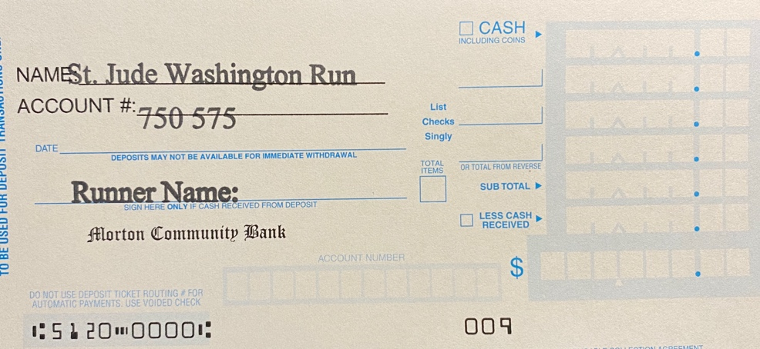

Out of town runners can mail checks to: Washington Community Bank, 1895 Washington Road, Washington, IL 61571. Be sure to include your name with the deposit.

Please be sure to record donor name and donation amount on all CASH donations $250 and above by submitting the required information on the following link: http://stjuderuns.org/forms/donations-250/

Questions?
Tyler Davis – St. Jude Washington Run Treasurer
E-mail: utrocket2000@gmail.com

